

CORE® technology is an online experiential software management program that the University of Findlay College of Pharmacy is utilizing to help manage the experiential process. If you have not already received an email from CORE/ELMS® informing you of your login and password, please let us know and we can send this to you, through the email you provide us. This is not a complete manual but is intended to help you become familiar with the basic functions of CORE/ELMS®. Please note the instructions below.

To access CORE/ELMS:
- Go to https://corehighered.com/login-elms
- Your login page automatically pops up.
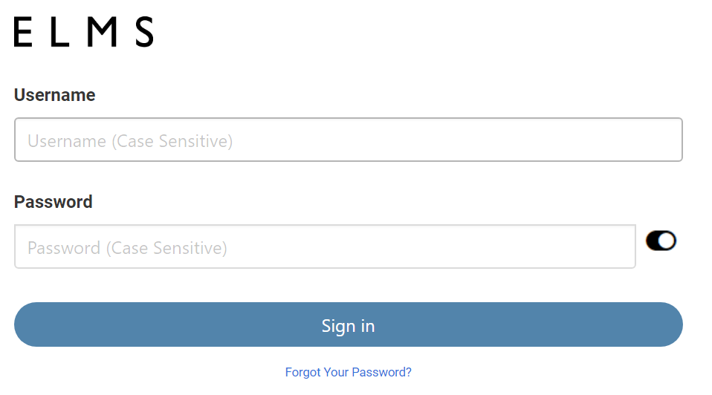

- Enter your Log in & password which you should’ve received when your account was created with us. If you forget or lose your information, contact Don Emmert at emmertd1@findlay.edu or 419-434-5633)

- To view Schedule:
Click on “Scheduling” located on the left side of the screen.
- Review your schedule by clicking on the sub tab “Rotation Schedule”
- Click on the student’s name under to email them if there is something you want or need to tell them before the rotation.
- Click on  (if the student has linked his/her account) and review their portfolio.
- Once logged in to MyCred, scroll down and look for the tab
    - “Resume & CV”
- Click on “Resume & CV” and click on the Resume/ CV, word document that the student has created. Please note it is very important for students to have their resume/CVs reviewed. This process should be helpful to you and the student; it helps you to know what their strengths, weaknesses, and past experiences have been. This gives you, the educator, a starting point to focus on during their experiential education.

Go back to CORE/ELMS by closing the MyCred browser tab. Here you will complete evaluations and confirm hours.

- Evaluations (provide student & review student evaluation of preceptor)
Submissions for Advance Practice Preceptors (APPE) P6-students:
Click on the far-left tabs “Evaluations” then click on the sub heading tab “Evaluation of Student”; there are 3 evaluations: a mid-point (done week 2), final evaluation, and final grade assignment. The grading scale is A=honors, B= pass, or F= fail. If the student fails the rotation then he/she must repeat the month, either with the current preceptor or a different preceptor.
  - The final evaluation and grade assignment must be done at the end of each month. Mid-point evaluations are required to provide direction for the student.
  - Note example below: Simply clicking on the title of the evaluation will permit you to bring up the evaluations & final grade submission.

Submissions for IPPE students are the same instructions, but IPPEs do not have mid-points.

Students | Grad Year | Rotation Dates | Rotation Types | Evaluations
Test Student | 2013 | 07-02-12 - 07-31-12 | Elective 1 | Advanced Practice- Pharm.D. Student Rotation Grade (PHAR 701-710)
Test Student | 2013 | 07-02-12 - 07-31-12 | Elective 1 | Advanced Practice-Pharm.D. Student Rotation Midpoint & Final Evaluation Form (PHAR 701-710)

  - Viewing student evaluations of you: Click on the far-left tab “Evaluations” then click on the sub-heading tab “Evaluation of Preceptor/Site”

Students | Grad Year | Rotation Dates | Rotation Types | Evaluations
Anonymous Student | -- | -- | -- | Advanced Practice Preceptor Evaluation Form

- Documenting IPPE/APPE Hours
Preceptors are expected to confirm student hours. On the left-hand side click on “Hours Tracking.” As a preceptor, it is expected that you will log into CORE/ELMS and confirm hours. Under the “Student Hours Tracking” page, you can verify the date and time that your student has spent with you. APPE hours may be logged monthly by the student and should be verified by the end of the experience. The University of Findlay experiential faculty will review the student’s submission after the preceptor has confirmed the hours.
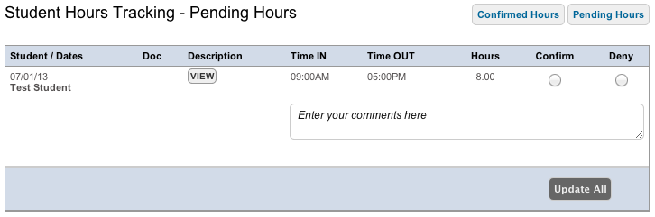
- Documenting Absences:

If a student has an absence, they are instructed to inform you as soon as possible. Both excused and unexcused absences must be recorded by the student. If a student has an excused absence (refer to Pharm.D. APPE manual for details), we ask that you confirm this in CORE/ELMS. To confirm an absence, click on “Absences” on the left side of the screen. It will be marked with yellow arrow when you have an absence to approve. Please feel free to make comments as you see necessary regarding the absence and or contact the experiential faculty if there is an absence issue.

7. Documenting Preceptor Training:
We encourage and offer preceptor training through the College of Pharmacy Experiential Program.
Any time you complete preceptor training (on campus, at a national meeting, via CEI, or even through another college’s experiential program), please document this under the “My Requirements” tab found on the left side of the screen. Scroll down to the folder titled “Level I – University of Findlay Preceptor.” Click “Edit” next to “Preceptor Training Program” and in the comment box, note the type of preceptor training you have completed and the date. (Please leave the expiration date field blank).
Then click the “Status” radio button that says “Complete.” Then hit “Enter Requirement.” If you gain additional training at a later date, simply add the additional training and dates to the comment box. This is on the honor system, and we do not require you to send us a copy of your CE.

If you have any questions, please feel free to contact us.

Tonya Dauterman, Pharm.D. , CGP, CDE Lori Colchagoff, M.Ed.
Director of Experiential Education Experiential Education Specialist
Assistant Professor, Pharmacy Practice The University of Findlay College of Pharmacy
The University of Findlay College of Pharmacy 1000 North Main Street
1000 North Main Street Findlay, Ohio 45840
Findlay Ohio 45840 419-434-5462
419-434-5449 Fax: 419-434-5583
Fax: 419-434-5583 lcolchagoff@findlay.edu
dauterman@findlay.edu

Tim Burkart, Pharm.D., BCPS, CGP Don Emmert, MBA
Assistant Director Of Experiential Education Experiential Education Specialist
Assistant Professor, Pharmacy Practice The University of Findlay College of Pharmacy
The University of Findlay College of Pharmacy 1000 North Main Street
1000 North Main Street Findlay, Ohio 45840
Findlay, Ohio 45840 419-434-5633
Phone: 419-434-5783 Fax: 419-434-5583
Fax: 419-434-5583 emmertd1@findlay.edu
burkart@findlay.edu

Cassey Bolyard, MBA
Experiential Education Specialist
The University of Findlay College of Pharmacy
1000 North Main Street
Findlay, Ohio 45840
419-434-5633
Fax: 419-434-5583
cassey.bolyard@findlay.edu

